**Brief Report on Flights Delays**

Note: All the delay analysis are done based on arrival delays instead of departure delays, as the data of delay reasons given by the dataset are based on arrival delays.

# **Each Delay Reason/Total delays (in minutes)**

**In general**

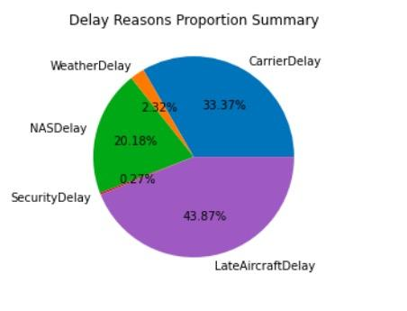

**Arrival Airport: LAX**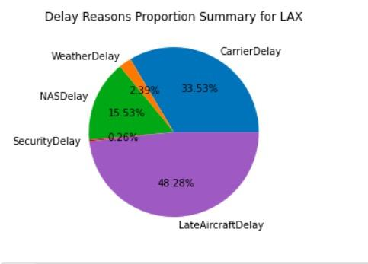

**Arrival Airport: LAS**

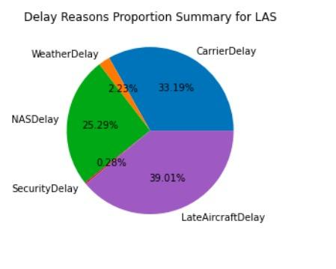

**Comparison of each cause of delay and their trends every six months**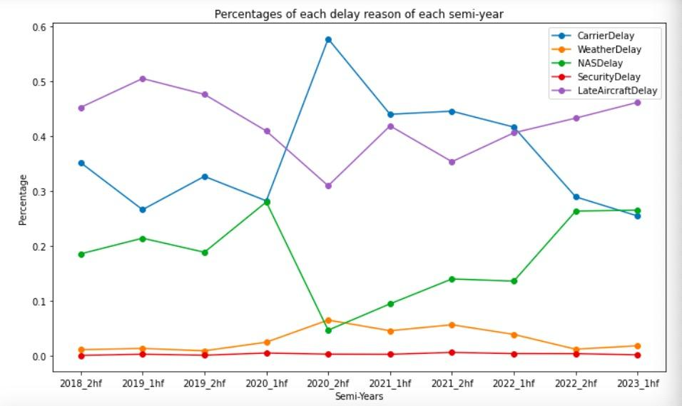

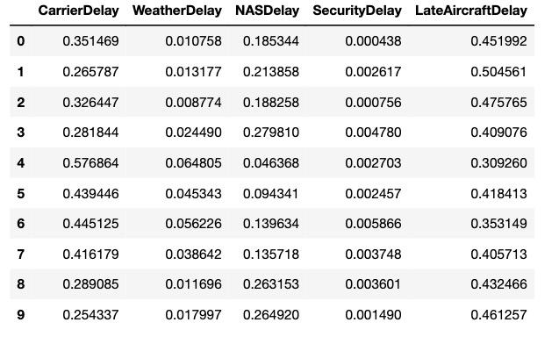

Table for the curve chat above

# **Percentages of how many times that each delay reason had contributed to the delay (including unknown reasons). Their summation does not equal to 1 as every reason was calculated independently.**

# **In general**

# 

**Arrival airport: LAX**

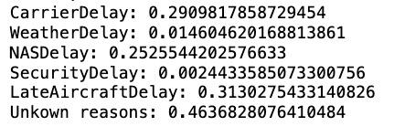

**Arrival Airport: LAS**

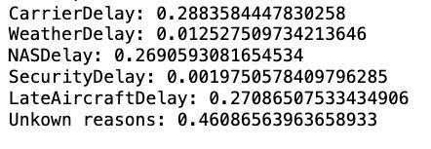

1. **Others**

All the dataframes that were used to plot the chats can be achieved in .csv form by the code provided in the last cell of *Flights Delay Analysis.ipynb*, just for your convenience.